Mid Compensate Assignment

Name: | XXX
Student ID: | XXX
Section: | XXX
Program: | XXX
Department: | XXX

Table of Contents

INTRODUCTION 3
Topic 1 3
Sub-Title 1 3
Sub-Title 2 3
Topic 2 5
Sub-Title 1 5
Sub-Title 2 5
CONCLUSION 6
References 6
APPENDIX A 7

INTRODUCTION
This section sets up the reader for the rest of the report. When writing an introduction, it is important to keep in mind the understanding and experience of the prospective reader. Often it contains background information to show how this work fits into the general body of knowledge. [1]
The format in this template is the recommended way to write assignments. The goal of a report should be to present the information as clearly and completely as possible, while still concentrating on being concise. Write in complete sentences using a passive voice, taking care to avoid grammatical errors. Reports should be prepared as single sided page documents.

Topic 1
The work being reported should be broken up into logical sections with appropriate headings to indicate the content of each section. Thus, section headings in the main body of the text will vary according to the type of assignment being reported. Body text is to be in Times New Roman 11 points single spaced with one spacing between each paragraph. Leave one blank line between main section headings. All section main headings are to be in Times New Roman 13 point bold and sub-headings should be in Times New Roman 12 point bold. [2]

Sub-Title 1
Section headings should tell the reader exactly what type of information is contained in the section. They should be specific and content-focused rather than just labels. Devising informative headings as opposed to label headings right from the planning stage will help you to clarify exactly what you want to achieve in each section and subsection. The following provides an illustration of both uninformative headings and informative headings: [3]
Uninformative headings
- The organisatio
- Management
Informative headings
- Overview of the organisation
- Communication in the organisation
- Groups in the organisation
- Management style and methods

Sub-Title 2
Section headings should tell the reader exactly what type of information is contained in the section. They should be specific and content-focused rather than just labels. Devising informative headings as opposed to label headings right from the planning stage will help you to clarify exactly what you want to achieve in each section and subsection. The following provides an illustration of both uninformative headings and informative headings:

Table 1 Estimated engine shaft power requirements for vessel A.
Vessel | Engine
Speed | Shaft Power
(knots) | (kW)
4 | 9
6 | 36
8 | 95
10 | 249
12 | 604
14 | 1667

Topic 2
The work being reported should be broken up into logical sections with appropriate headings to indicate the content of each section. Thus, section headings in the main body of the text will vary according to the type of assignment being reported. Body text is to be in Times New Roman 11 points single spaced with one spacing between each paragraph. Leave one blank line between main section headings. All section main headings are to be in Times New Roman 13 point bold and sub-headings should be in Times New Roman 12 point bold.

Sub-Title 1
Section headings should tell the reader exactly what type of information is contained in the section. They should be specific and content-focused rather than just labels. Devising informative headings as opposed to label headings right from the planning stage will help you to clarify exactly what you want to achieve in each section and subsection. The following provides an illustration of both uninformative headings and informative headings:
Uninformative headings
- The organisatio
- Management
Informative headings
- Overview of the organisation
- Communication in the organisation
- Groups in the organisation
- Management style and methods

Sub-Title 2
Section headings should tell the reader exactly what type of information is contained in the section. They should be specific and content-focused rather than just labels. Devising informative headings as opposed to label headings right from the planning stage will help you to clarify exactly what you want to achieve in each section and subsection. The following provides an illustration of both uninformative headings and informative headings:

Where you have a choice, all graphs should be positioned so that they can be read with the page in its normal position. This will always be possible with portrait-style graphs where the y-axis is longer than the x-axis.
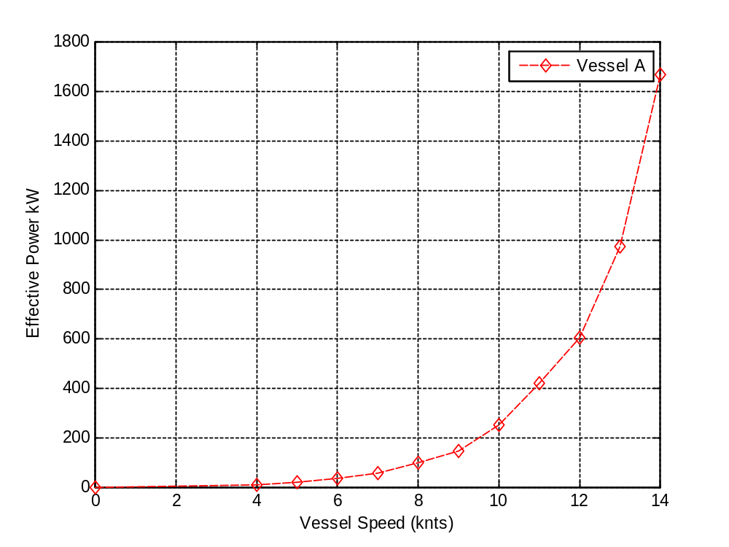
Figure 1 Estimated Powering requirements for vessel A.

CONCLUSION
This section is a summary of the most important thoughts contained in the main body of the text, and nothing should appear here that has not been discussed previously. The conclusions follow logically from what has gone before. Short thoughtful conclusions should be used.

References
- Reeves, T.C., & Laffey, J.M. (1999). Design, assessment, and evaluation of a problem-based learning environment in undergraduate engineering. Higher Education Research and Development Journal, 18(2), 219-232.
- Woud, H. K., & Stapersma, D. (2002). Design of Propulsion and Electric Power Generation Systems, London: IMarEST.
- http://utas.libguides.com/content.php?pid=27520&sid=199805

APPENDIX A

This section is optional. Appendices are used for very detailed or lengthy sections of information. Information placed in an Appendix is usually supplementary to, or supportive of the discussion in the body of the report, but usually it is not critical to the main points being made in the report.
Appendices are referenced using letters, i.e. Appendix A, Appendix B, etc. Each appendix always starts on a new page.

